**Energy**

Energy transformations (changes) are **always** associated with chemical and physical reactions.

Some chemical and physical processes release energy to the surroundings. These are *exothermic* reactions.

Some chemical and physical processes absorb energy from the surroundings. These are *endothermic* reactions.

Energy released or absorbed can be in the form of **HEAT, LIGHT, ELECTRICITY, SOUND** or **MECHANICAL** (ie. an explosion).

All chemical and physical processes are **'driven'** by either one or both of two 'driving forces'. :The tendency to move to the state of ***minimum enthalpy*** (total energy), and the tendency to move to a state of ***maximum entropy*** (randomness or disorder).

In an **ENDOTHERMIC** process, the energy absorbed is converted into potential energy, thereby increasing the potential energy (or enthalpy) of the reactants. The products are at a higher potential energy state (and therefore higher enthalpy state) than the reactants. The products, which would have weaker interatomic and/or intermolecular bonds, are said to be less stable than the reactants.

In an **EXOTHERMIC** process, the energy released has been converted from the potential energy originally stored in the reactants, thereby decreasing the potential energy (or enthalpy) of the reactants. The products are at a lower potential energy state (and therefore lower enthalpy state) than the reactants. The products, which would have stronger inter-atomic and/or intermolecular bonds, are said to be more stable than the reactants.

All reactions involve **bond-breaking** and/or **bond-forming** processes. Breaking of a chemical bond always requires the *input* of energy, ie. Energy is required to break bonds, while the formation of a chemical bond always *releases* energy.

∆H (reaction), the change in enthalpies between the reactants and products is equal in value to the actual amount of energy released or absorbed in the reaction. The ∆H (reaction), or simply ∆H, is defined as the enthalpy of the products minus the enthalpy of the reactants.

∆H(reaction) 'means H­p - Hr '

∆H(reaction) is **negative** for an ***exothermic*** reaction since H(products) is less than H(reactants).

∆H(reaction) is **positive** for an ***endothermic*** reaction since H(products) is greater than H(reactants).

If 1.0 moles of a particular reactant reacts to release or absorb a certain amount of energy, then 0.5 moles of the reactant will release or absorb half as much energy due to half the number of bonds being broken and formed.

**Set 1**

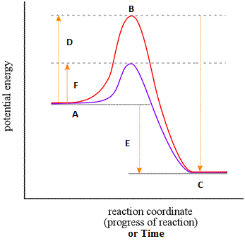**Match the following statements with the letters.**

___ Activation energy of the forward catalysed reaction.

**G**

___ Enthalpy of the reactants for the forward reaction.

___ Enthalpy of the products for the forward reaction.

___ Change in enthalpy, ∆H for the reaction.

___ Activation energy of the forward reaction.

___ Activation energy for the reverse reaction.

___ Relative energy of the activated complex.

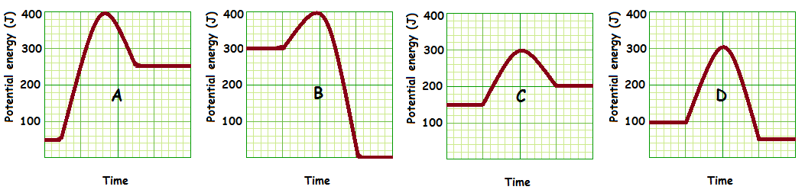**Match the letter of the graph with the following descriptions.**

___ shows the graph with forward reaction showing the lowest initial energy state of the reactants.

___ shows the greatest activation energy for the forward reaction.

___ represents the reaction with the greatest change in enthalpy.

___ represents an endothermic forward reaction (answer with two graphs).

___ represents an exothermic forward reaction (answer with two graphs).

___ would benefit the most from the addition of a catalyst.

___ shows the greatest activation energy for the reverse reaction.

**For these questions read the graphs above.**

______ What is the activation energy of the forward reaction in diagram B?

______ What is the change in enthalpy for the forward reaction in diagram A?

______ Is the reaction described in B endothermic or exothermic?

**Set 1 - Answers**

**Match the following statements with the letters.**

_**F**_ Activation energy of the forward catalysed reaction.

**G**

_**A**_ Enthalpy of the products for the forward reaction.

_**C**_ Enthalpy of the products for the forward reaction.

_**E**_ Change in enthalpy, ∆H for the reaction.

_**D**_ Activation energy of the forward reaction.

_**G**_ Activation energy for the reverse reaction.

_**B**_ Relative energy of the activated complex.

**Match the letter of the graph with the following descriptions.**

**_A_** shows the graph with forward reaction showing the lowest initial energy state of the reactants.

**_A_** shows the greatest activation energy for the forward reaction.

**_B_** represents the reaction with the greatest change in enthalpy.

**A&C** represents an endothermic forward reaction (answer with two graphs).

**B&D** represents an exothermic forward reaction (answer with two graphs).

**_A_** would benefit the most from the addition of a catalyst.

**_B_** shows the greatest activation energy for the reverse reaction.

**For these questions read the graphs above.**

**_100 J_** What is the activation energy of the forward reaction in diagram B?

**+200 J** What is the change in enthalpy for the forward reaction in diagram A?

**Exothermic** Is the reaction described in B endothermic or exothermic?

**Set 2**

1. For the Reaction A + B 🠂 C + D, the energy level diagram is shown below:

a) Label the above diagram with the following numerals:

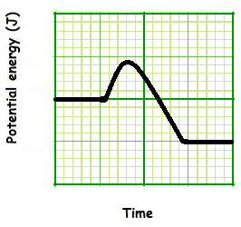

(i) enthalpy of reactants

(ii) enthalpy of products

(iii) enthalpy of energy

(iv) activated complex

(v) enthalpy change in the reaction, ∆H(reaction).

b) The above reaction is EXOTHERMIC / ENDOTHERMIC. This is because ____________________________

_______________________________________________________________________________________

2. For the reaction X + Y 🠂 2Z, the ∆H(reaction) is -100kJ. Explain where this energy has come from.

_______________________________________________________________________________________

_______________________________________________________________________________________

3. Circle each of the following reactions stating whether they are exothermic or endothermic:

a) 2H­2(g) + O2(g) 🠂 2H2O ; ∆H(reaction) = -570kJ EXOTHERMIC / ENDOTHERMIC

b) N2(g) + O2(g) 🠂 2NO ; ∆H = +180 kJ EXOTHERMIC / ENDOTHERMIC

c) 2CO(g) + O­2­(g) 🠂 2CO2(g) + 570kJ EXOTHERMIC / ENDOTHERMIC

d) 2SO2(g) + O2(g) 🠂 2SO(g) ; ∆H = -197 kJ EXOTHERMIC / ENDOTHERMIC

e) 6CO2(g) + 6H2O(l) + 2802 kJ 🠂 C6H12O6(s) + 6O2(g) EXOTHERMIC / ENDOTHERMIC

f) P4(s) + 5O2(g) 🠂 P4O10(s) ; ∆H(reaction) = -3007 kJ EXOTHERMIC / ENDOTHERMIC

4. At high temperatures, solid lead (II) nitrate, Pb(NO3)2 , decomposes to form solid lead (II) oxide, oxygen gas, and gaseous nitrogen dioxide. This decomposition absorbs 291 kJ of energy per mole of lead (II) nitrate decomposed.

a) Write a balanced chemical equation for this reaction, and include the energy term as part of the equation.

_______________________________________________________________________________________

b) State whether the reaction is exothermic or endothermic.

_______________________________________________________________________________________

5. For the reaction N2(g) + O2(g) 🠂 2NO(g), the energy level diagram is shown below

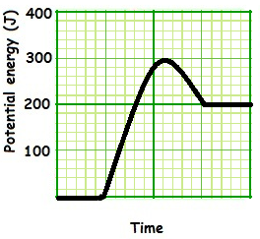

a) State whether the reaction is exothermic or endothermic. _____________________

b) State the actual values for

i) activation energy _____________________

ii) ∆H(reaction) _____________________

6. For the reaction X(s) + Y(g) 🠂 3Z (g) + W(g), the energy-level diagram is below:

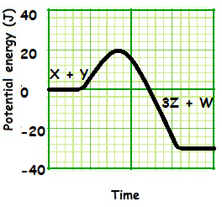

Determine the values, in Joules (J), and ensure you write the SIGN (+/-) to state your value;

a) The ∆H for the forward reaction. _____________________

b) The activation energy for the forward reaction. _____________________

c) ∆H for the reverse reaction. _____________________

d)The activation energy for the reverse reaction. _____________________

**Set 2 - Answers**

1. For the Reaction A + B 🠂 C + D, the energy level diagram is shown below:

a) Label the above diagram with the following numerals:



(iv)

(iii)

(i)

(v)

(ii)

(i) enthalpy of reactants

(ii) enthalpy of products

(iii) activation energy

(iv) activated complex

(v) enthalpy change in the reaction, ∆H(reaction).

b) The above reaction is EXOTHERMIC / ~~ENDOTHERMIC.~~ This is because _the enthalpy of the products is

less than that of the products. Therefore the reaction system has lost energy to the surroundings. _______

2. For the reaction X + Y 🠂 **2**Z, the ∆H(reaction) is -100kJ. Explain where this energy has come from.

The energy required to break the bonds is less than the energy released when new bonds form. The

difference in this energy is given out as heat energy to the surroundings.

3. Circle each of the following reactions stating whether they are exothermic or endothermic:

a) 2H­2(g) + O2(g) 🠂 2H2O ; ∆H(reaction) = -570kJ EXOTHERMIC ~~/ ENDOTHERMIC~~

b) N2(g) + O2(g) 🠂 2NO ; ∆H = +180 kJ ~~EXOTHERMIC /~~ ENDOTHERMIC

c) 2CO(g) + O­2­(g) 🠂 2CO2(g) + 570kJ EXOTHERMIC ~~/ ENDOTHERMIC~~

d) 2SO2(g) + O2(g) 🠂 2SO(g) ; ∆H = -197 kJ EXOTHERMIC ~~/ ENDOTHERMIC~~

e) 6CO2(g) + 6H2O(l) + 2802 kJ 🠂 C6H12O6(s) + 6O2(g) ~~EXOTHERMIC /~~ ENDOTHERMIC

f) P4(s) + 5O2(g) 🠂 P4O10(s) ; ∆H(reaction) = -3007 kJ EXOTHERMIC ~~/ ENDOTHERMIC~~

4. At high temperatures, solid lead (II) nitrate, Pb(NO3)2 , decomposes to form solid lead (II) oxide, oxygen gas, and gaseous nitrogen dioxide. This decomposition absorbs 291 kJ of energy per mole of lead (II) nitrate decomposed.

a) Write a balanced chemical equation for this reaction, and include the energy term as part of the equation.

___ 2Pb(NO3)2 + 582kJ 🠂 2PbO + O2 + 4NO2 __________________________________________________

b) State whether the reaction is exothermic or endothermic.

___ENDOTHERMIC_________________________________________________________________________

5. For the reaction N2(g) + O2(g) 🠂 2NO(g), the energy level diagram is shown below



a) State whether the reaction is exothermic or endothermic. ___ENDOTHERMIC__________________

b) State the actual values for

i) activation energy _____300 J____________

ii) ∆H(reaction) _____200 J____________

6. For the reaction X(s) + Y(g) 🠂 3Z (g) + W(g), the energy-level diagram is below:



Determine the values, in Joules (J), and ensure you write the SIGN (+/-) to state your value;

a) The ∆H for the forward reaction. ___-30 J_____________

b) The activation energy for the forward reaction. ___+20 J_____________

c) ∆H for the reverse reaction. ___+30 J_____________

d)The activation energy for the reverse reaction. ___+50 J_____________

**Set 3**

1. Consider the following reaction:

A(s) + X2(g) 🠂 AX2(s)

In this reaction, 150kJ of heat energy are released. The activation energy for the reaction has been estimated at 200 kJ.

a) State the ∆H for the reaction. ___ ______________________

b) Draw the energy-level diagram for this reaction, and label it with the following;

i) Ground state enthalpy of reactants and products

ii) ∆H(reaction)

iii) Activation energy



2. **Rewrite** the following equations, stating the ∆H(reaction) ;

a)2Na(s) + Cl2(g) 🠂 2NaCl(s) + 822kJ

b) 2CO(g) + 230kJ 🠂 2C(s) + O2(g)

c) CaO(s) + 2HCl(aq) 🠂 CaCl­2(aq) +261kJ+H2­O(l)

**Rewrite** the following equations, writing the enthalpy value as either a reactant or a product.

d) H2(g) + F2(g) 🠂 2HF(g) ; ∆H = -538kJ

e) H2(g) 🠂 2H(g) ; ∆H = +436kJ

f) 4H(g) 🠂 2H2(g) ; ∆H = -872kJ

3. **TICK** whether each reaction is EXOTHERMIC or ENDOTHEMRIC from question 2.

|  |  |  |
| --- | --- | --- |
|  | EXOTHERMIC | ENDOTHERMIC |
| a) |  |  |
| b) |  |  |
| c) |  |  |
| d) |  |  |
| e) |  |  |
| f) |  |  |

4. **Draw** an enthalpy profile diagram to scale for each of the reactions in question 2 and include the ∆H in each case.





5. **State** any differences and/or similarities between reactions and their corresponding ∆H in reactions (e) and (f) of questions 2, 3 and 4. **Explain** this significance in terms of *energy conservation (Hess law)*.

________________________________________________________________________________________

________________________________________________________________________________________

________________________________________________________________________________________

________________________________________________________________________________________

**Set 3 - Answers**

1. Consider the following reaction:

A(s) + X2(g) 🠂 AX2(s)

In this reaction, 150kJ of heat energy are released. The activation energy for the reaction has been estimated at 200 kJ.

a) State the ∆H for the reaction. ___-150 kJ ______________________

b) Draw the energy-level diagram for this reaction, and label it with the following;

i) Ground state enthalpy of reactants and products

ii) ∆H(reaction)

iii) Activation energy



2. **Rewrite** the following equations, stating the ∆H(reaction) ;

a)2Na(s) + Cl2(g) 🠂 2NaCl(s) + 822kJ

2Na(s) + Cl2(g) 🠂 2NaCl(s); **∆H = - 822kJ**

b) 2CO(g) + 230kJ 🠂 2C(s) + O2(g)

2CO(g) 🠂 2C(s) + O2(g) ; **∆H = + 230kJ**

c) CaO(s) + 2HCl(aq) 🠂 CaCl­2(aq) +261kJ+H2­O(l)

CaO(s) + 2HCl(aq) 🠂 CaCl­2(aq) +H2­O(l) ; **∆H = - 261kJ**

**Rewrite** the following equations, writing the enthalpy value as either a reactant or a product.

d) H2(g) + F2(g) 🠂 2HF(g) ; ∆H = -538kJ

H2(g) + F2(g) 🠂 2HF(g) + 538kJ

e) H2(g) 🠂 2H(g) ; ∆H = +436kJ

H2(g) +436kJ 🠂 2H(g)

f) 4H(g) 🠂 2H2(g) ; ∆H = -872kJ

4H(g) 🠂 2H2(g) + 872kJ

3. **TICK** whether each reaction is EXOTHERMIC or ENDOTHEMRIC

|  |  |  |
| --- | --- | --- |
|  | EXOTHERMIC | ENDOTHERMIC |
| a) |  |  |
| b) |  |  |
| c) |  |  |
| d) |  |  |
| e) |  |  |
| f) |  |  |

4. **Draw** an enthalpy profile diagram to scale for each of the reactions in question 2 and include the ∆H in each case.



5. **State** any differences and/or similarities between reactions and their corresponding ∆H in reactions (e) and (f) of questions 2, 3 and 4. **Explain** this significance in terms of *energy conservation (Hess law)*.

Similarities include that it is the same reagents involved in either the reactants or the products so it’s the

change in enthalpy just in the opposite direction **[1]** Differences include the number of moles involved in e)

is exactly half that of the moles involved with f) so therefore its enthalpy change is half that of f). **[1]**

One of the reactions is a forward reaction where the other is the reverse reaction therefore making one

exothermic and the other endothermic. **[1]**____________________________________________________